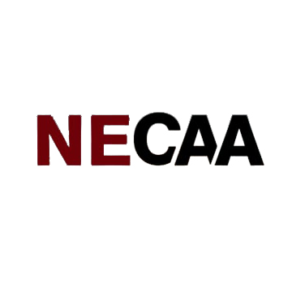
Nebraska County Attorneys Association

New County Attorney Boot Camp

Lincoln Marriott Cornhusker Hotel

333 S 13th St, Lincoln, Nebraska 68508
On-Line Registration and Lodging Available

Presenters Subject to Change

Thursday, January 24, 2019

9:00 – 9:10 AM Welcome
James Smith, NECAA President
NE Attorney General, Doug Peterson
9:10 – 10 AM Open Meeting Laws | Public Records
Leslie Donley, AGO
10:00 – 10:30 AM County Board & County Budgets, Shawn Eatherton, Buffalo County
10:30 – 11:15 AM County Coroner Duties
Shawn Eatherton, Buffalo County; Paul Schaub, Cheyenne County; Dr. Robert Bowen, Douglas County Coroner

11:15 AM – 12:00 PM Mental Health|Sex
Offender Commitment|Adult Developmental Disability Custody,
Wes Netspor, NHHS
Noon – 1:00 PM Lunch
Plea Negotiations
Brenda Beadle, Douglas County
1:00 – 1:30 PM Jury Selection Process
Eric Miller, Lancaster County

1:30 – 2:00 PM Preliminary Hearings; Bonds; Plea
In Abatement, David Partsch, Otoe
County
2:00 – 3:00 PM Dealing with the Media
Pat Condon, Lancaster County

3:15 – 4:00 PM Legislature 101 – Zulkoski|Weber

4:00 – 5:30 PM Legislative Review

5:30 PM Adjourn
Friday, January 25, 2019

8:00 – 9:00 AM Warrants | Search & Seizure
Corey O’Brien, AGO

9:00 – 10:30 AM Juvenile Diversion & Juvenile Court
Chris Turner, Lancaster County

10:30 – 11:30 AM DUI|DRE and Speeding
Ed Vierk, AGO

11:30 AM – 12:30 PM Lunch
Appeals & Post Convictions
James Smith, AGO

12:30 – 1:30 PM Domestic Violence & Sexual Assault, George Welch, AGO

1:30 – 2:00 PM TERC | Inheritance Tax
Jon Schroeder, Frontier County

2:00 – 2:30 PM Tax Foreclosure
Paul Schaub, Cheyenne County

2:30 – 3:00 PM Child Support
Margaret Ewing, NHHS

3:00 PM Adjourn

Judiciary Hearing | Nebraska State Capitol

On-Line Registration and Lodging Available

